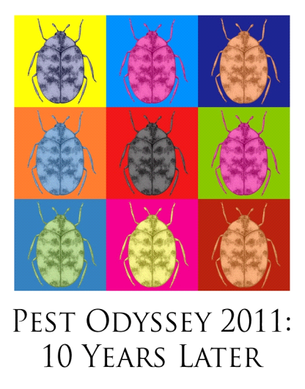 | Pest Odyssey 2011:  10 years later  26 – 28 October 2011
Booking Form

Fees (please tick as appropriate)
□ | £210 | Early Bird (available until 30 June 2011 inclusive) and all Speakers
□ | £270 | Standard Fee (available from 1 July until 25 October inclusive)
□ | £50 | Dinner at the Natural History Museum, 27 October 2011
□ | n/a | Pre-registration reception at the British Museum, 26 October 2011

*please note that day rates are not available

Icon Cancellation Policy
- Before 1 July 2011, a full refund less a £20 administration fee will be made.
- Cancellations made after 1 July 2011 and before 1 October 2011 will receive a 50% refund.
- After 1 October 2011, no refunds will be made although a replacement delegate may be sent, new
contact details must be forwarded to the office no later than 21 October 2011.

Personal Details
Name: | Icon Membership Number:
Organisation:
Address:

Telephone (day): Mobile:
Email:
Dietary Requirements:

Additional Requirements: (please list any special health or access requirements)

Are you a speaker at Pest Odyssey?

Payment Details (please tick as appropriate)
□ | Please invoice my organisation – I enclose an official purchase order  (NB: please note we cannot invoice individual members)
□ | I wish to pay £…………… by credit/debit card (excluding AmEx or Diners)
□ | Name on Card
□ | Card Number
□ | Start Date or Issue Number
□ | Expiry Date
□ | Security Code *
 | Signature
* 3 digit number on the reverse of your card, we are unable to process your payment without this.

□ | Please tick here if you require a receipt

When completed please email this form to conference@icon.org.uk. You will receive confirmation of your booking by email within 21 days.

Icon Office use only
Date Received |  | Invoice Sent |  | Payment Received
Date Processed |  | Receipt Sent |  | Confirmation Sent

